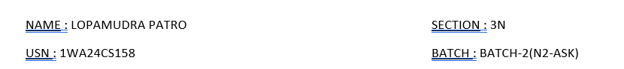

**DBMS LAB WEEK-2 INSURANCE DB MORE QUERIES/ ADDITIONAL QUERIES**

**Queries:**

1. **Display the entire CAR relation in the ascending order of manufacturing year.**
2. **Find the number of accidents in which cars belonging to a specific model (example 'Lancer') were involved.**
3. **Find the total number of people who owned cars that involved in accidents in 2008.**

**Query 1:**

SQL:

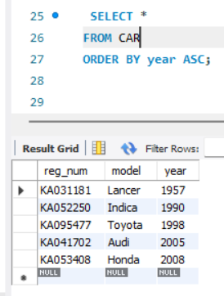

**QUERY-2**

Code type-1

select count(report_num)

from car c, participated p

where c.reg_num=p.reg_num and c.model='Lancer';

Alternate type code :

SQL:

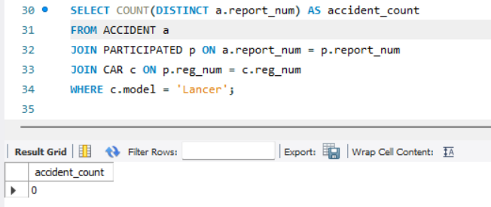

**QUERY-3:**

Code type- 1:

select count(distinct driver_id) CNT

from participated a, accident b

where a.report_num=b.report_num and b.accident_date like ‘_ _08%';

Alternate Type Code :

SQL :

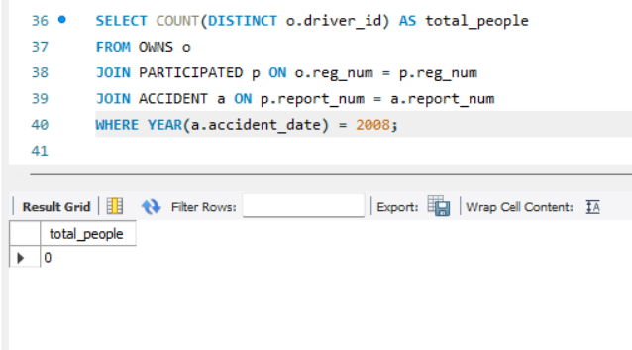

Database name here is insurance

**TO DO :**

* **LIST THE ENTIRE PARTICIPATED RELATION IN THE DESCENDING ORDER OF DAMAGE AMOUNT.**
* **FIND THE AVERAGE DAMAGE AMOUNT**
* **DELETE THE TUPLE WHOSE DAMAGE AMOUNT IS BELOW THE AVERAGE DAMAGE AMOUNT**
* **LIST THE NAME OF DRIVERS WHOSE DAMAGE IS GREATER THAN THE AVERAGE DAMAGE AMOUNT.**
* **FIND MAXIMUM DAMAGE AMOUNT.**

SQL:

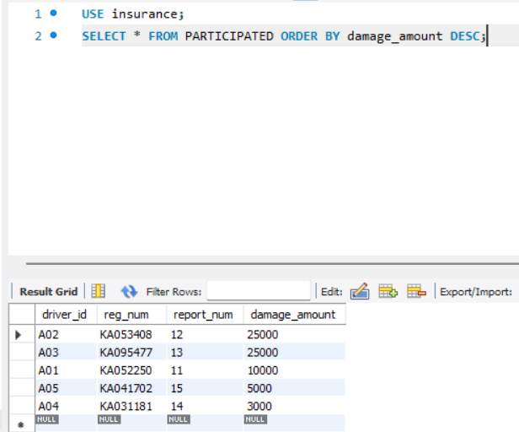

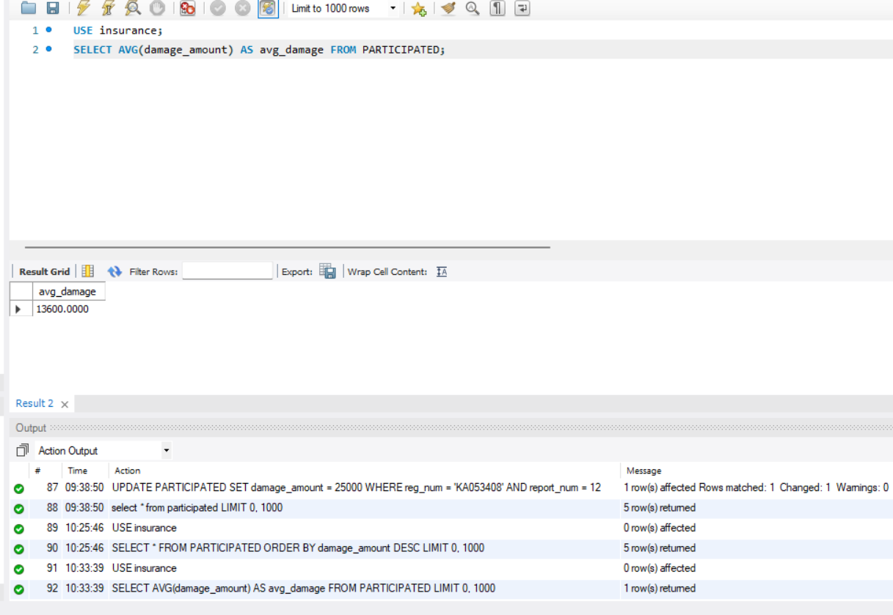

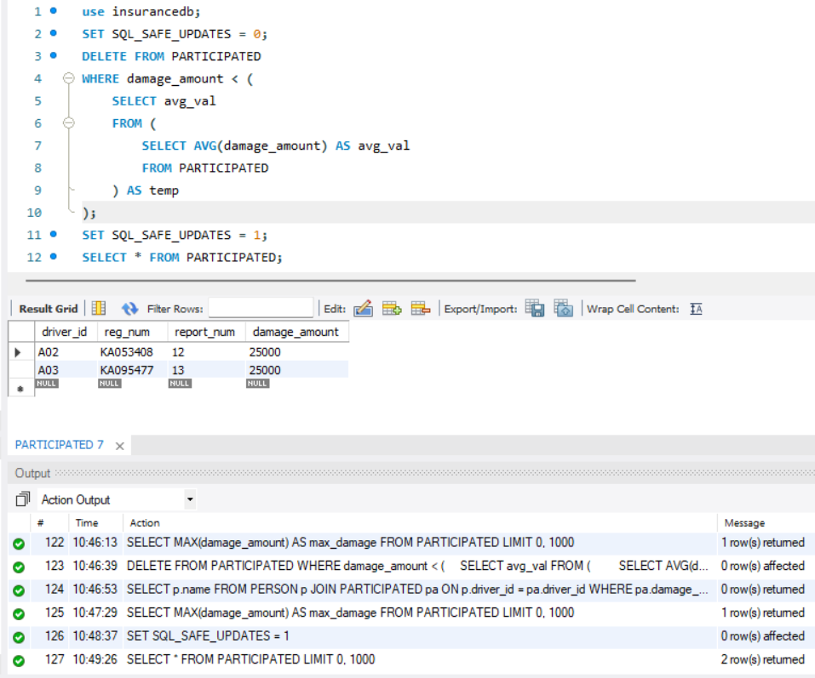

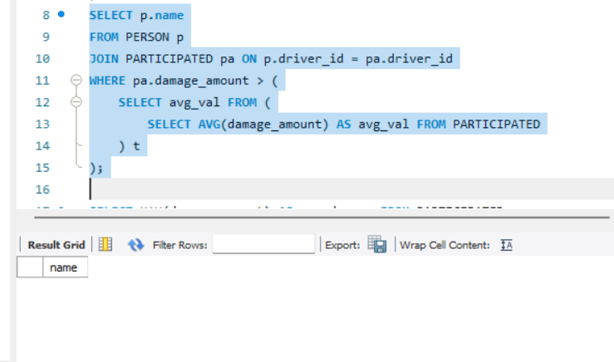

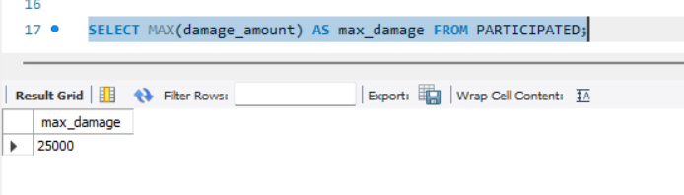

Thank you